#### INTRODUCTION

Traffic control and vehicle owner identification has become major problem in every country. Sometimes it becomes difficult to identify vehicle owner who violates traffic rules and drives too fast. Therefore, it is not possible to catch and punish those kinds of people because the traffic personal might not be able to retrieve vehicle number from the moving vehicle because of the speed of the vehicle. Therefore, there is a need to develop Automatic Number Plate Recognition (ANPR) system as a one of the solutions to this problem.

ANPR or license plate recognition (LPR) has been one of the useful approaches for vehicle surveillance. Special ANPR software reads the license plate characters from the camera image. The result is the ASCII or Unicode text of the plate. Character recognition helps in identifying and converting image text into editable text. As most of the number plate recognition algorithms use single method for character recognition. Most of the ANPR systems are based on common approaches like artificial neural network (ANN),Probabilistic neural network (PNN), Optical Character Recognition (OCR), Feature salient, MATLAB, Configurable method, Sliding concentrating window (SCW),neural network, support vector machine(SVM).

It is can be applied at number of public places for fulfilling some of the purposes like traffic safety enforcement, automatic toll text collection, car park system and Automatic vehicle parking system.

#### PROBLEM STATEMENT

Transportation is a base need of any industry. This is true for crime as for any legitimate business. Thus, if the required action is taken regarding vehicles affected by and used in crime, the overall crime rate for stealing of vehicles can be reduced. Effective identification and feed of such identification data in device will be useful to trace any stolen vehicle via the route it travels.

#### PROBLEM DESCRIPTION

In order to ensure that routing of a vehicle via license plate recognition is mainly considered whenever a car is been stolen from a certain location. Considering a situation of car being stolen from a specific location tracing a car from the nearest available camera which is present at signals or tollbooths are used for tracing purpose. License plate is traced using cameras nearest to the initial position to its current location which helps in finding car route which is stolen.

In our problem first we have to detect the number plate, so Most of the number plate detection algorithms fall in more than one category based on different techniques. Plate can be of different size in a vehicle image. And it can be located anywhere in the vehicle. A plate can have different background colors based on vehicle type. It may have screw and that could be considered as a character.

A number plate can be extracted by using image segmentation method. There are numerous image segmentation methods available in various literatures. In most of the methods image binarization is used. After locating number plate, characters are examined for the further process. As with the plate segmentation there are various methods available for conducting character segmentation.

#### OBJECTIVES

1. To provide a vehicle identification system which will be used by Government and the private sector to reduce, prevent and combat vehicle crime and crime in general.
2. The main objective of this project is to recognize the number plate of vehicle and track the vehicle after it is stolen from a certain place at certain time
3. By localizing the vehicle from the ANPR database of nearby cameras in the given timespan.

#### REQUIREMENT SPECIFICATION

Hardware Components of ANPR System

* Camera(s) – Digital cameras are used in the image acquisition stage. They are primarily used in obtaining images or video footage of vehicles.
* Infra-Red – Light source at night maybe provided by Infra-red in order to provide illumination for the camera.
* Frame Grabber – This is a hardware interface between the digital camera and the computer. The Frame Grabber is tasked with getting the digital image from the camera storing it temporarily and then submits it to the computer for processing.

Software Components of ANPR System

* OpenCV(Open Source Computer Vision) – This software has the OCR capabilities, which results in the extraction of the number plate from the digital image.
* Database – This provides storage for the data (number plates that have been read by the ANPR).

#### SYSTEM DESIGN

#### System Architecture:

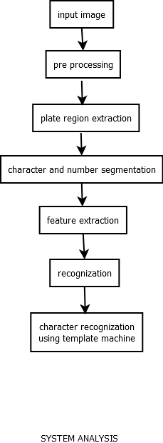

* 1. Used Case:

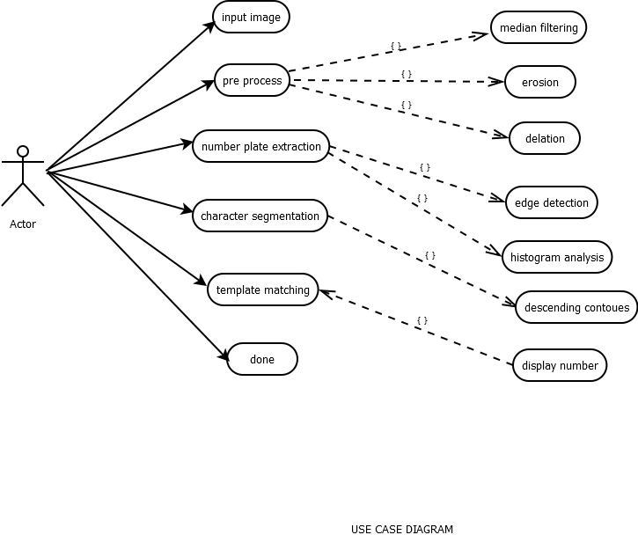

* 1. Data Flow Diagram:
     1. Level 0

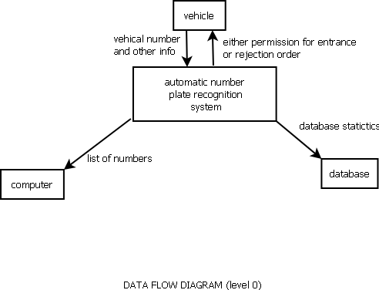

* + 1. Level 1

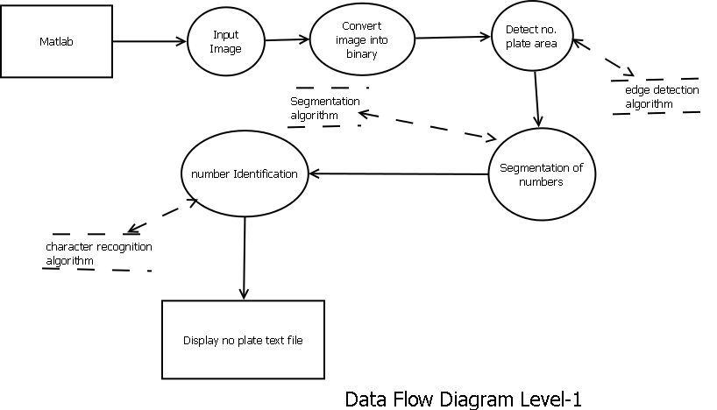

* 1. Activity Diagram

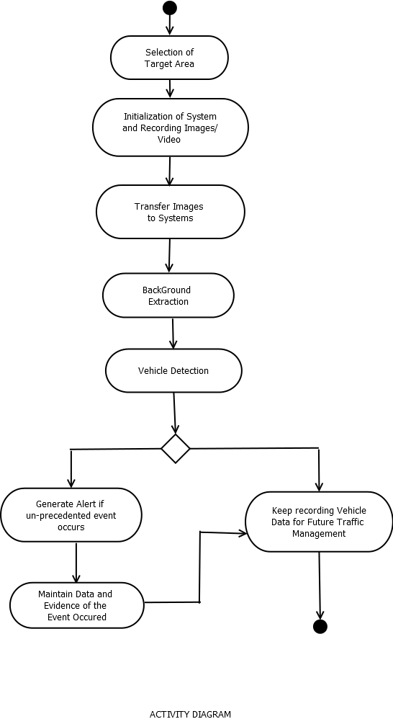

* 1. Sequence Diagram

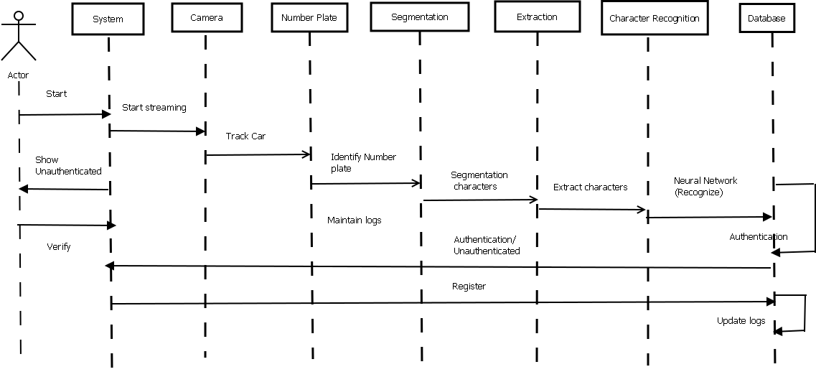

* 1. Flow Chart

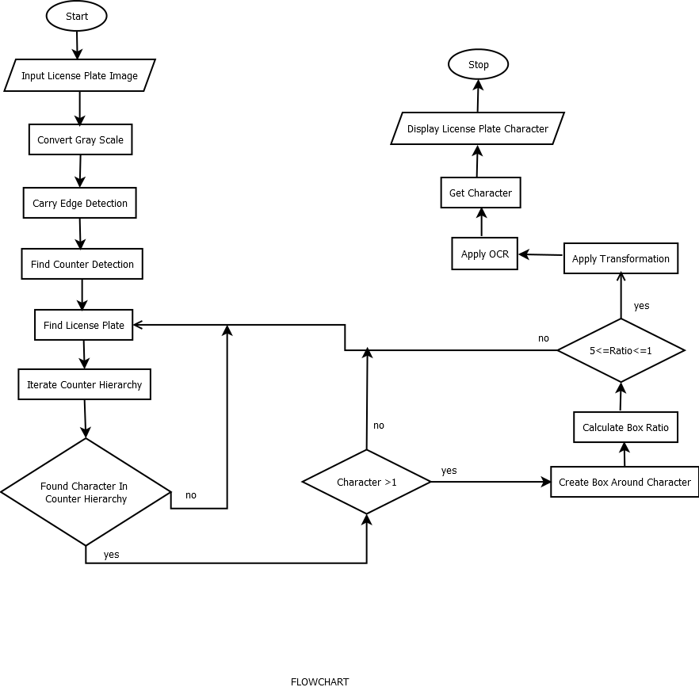

#### METHODOLOGY

In this section the process of automatic number plate recognition consists of four main stages:

* Image Acquisition

The first step is the image acquisition stage. The image of the vehicle is captured using a photographic camera. The constraint is that the image of the vehicle should be captured in such a way that the selected input image contains rear or front view of the vehicle with the number plate. The image is usually captured in a RGB (Red, Green and Blue) color model. The captured image is affected by many factors like: optical system, distortion, system noise, lack of exposure or excessive relative motion of camera or vehicle thus resulting in a degradation of a captured vehicle image hence adversely affecting the results of the overall image processing. As a correction mechanism, an image preprocessing stage is introduced to take care of any errors that may have occurred during the image acquisition stage. Image pre-processing mainly involves converting the RGB image into gray color, noise removal, and border enhancement for brightness. Image pre–processing is usually done through image filtering.

* Number Plate Detection

The next stage that follows is the number plate recognition phase that does several functions such as resizing of the image to a feasible aspect ratio. As well as converting the colored image into a grey scale, image. Number plate detection searches an input image in order to identify specific features that contain the number plate. The number plate can be found anywhere within an image, it is impractical to check all the pixels of the image in order to locate the number plate. Therefore, we only focus on those pixels that have the number plate.

* Character Segmentation

Character segmentation can be defined as a technique, which partitions images of lines or words into individual characters. It is an operation that seeks to decompose an image of a sequence of character into sub images of individual symbols. Character segmentation is an operation that seeks to decompose an image of a sequence of characters into subimages of individual symbols. Character segmentation is the process through which the text component within an image is isolated from the background. In order for proper text recognition to take place the line of text is first segmented, then from the segmented line the words are segmented and then from that the characters are segmented.

* Character Recognition

Character recognition is process of detecting and recognizing characters from input image and converting it into meaningful text in ASCII (American Standard Code for Information Interchange) or other equivalent machine editable form. Character recognition is the process to classify the input character according to the predefined character class. Template matching, or matrix matching, is one of the most common classification methods. In template matching, individual image pixels are used as features. Classification is performed by comparing an input character image with a set of templates from each character class. A very basic description of a functional ANPR process is:

* Step1: The camera takes a picture of the vehicle containing the number plate (Image acquisition).
* Step2: The camera isolates the plate, adjusts the brightness and contrast and segments it into characters (Number plate detection and Character segmentation).
* Step3: The pattern of each character is analyzed to convert the picture into text (Character recognition).

#### TESTING

Using the above proposed solution our group followed the coding with some sample images to test the percentage of achievement of our objective and analyzed various conditions to find and effectively overcome the errors.

Test case:

Multiple test cases were build up in format of images to understand the system efficiency. One of these is

Input Image --

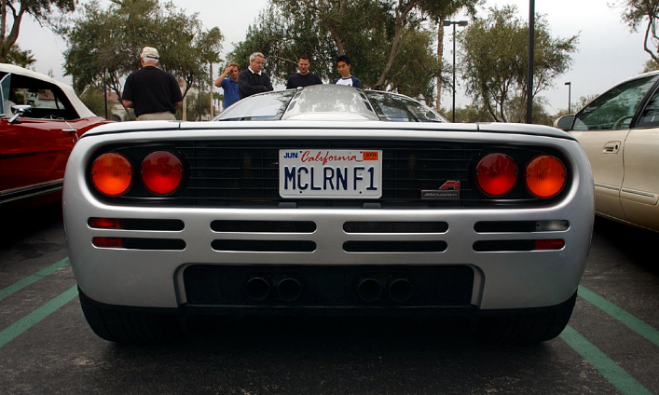

Output Image --

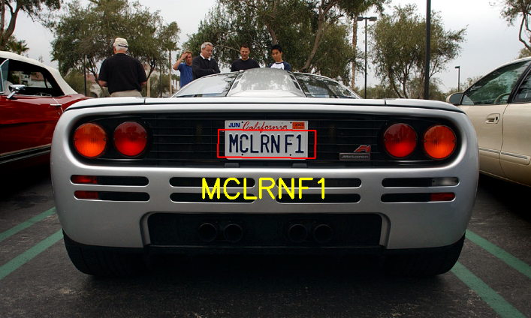

#### RESULT AND RESULT ANALYSIS

Result:-

Input Image

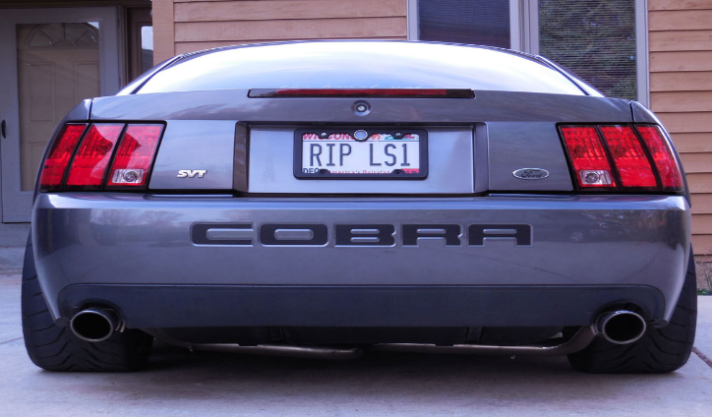

Output Image –

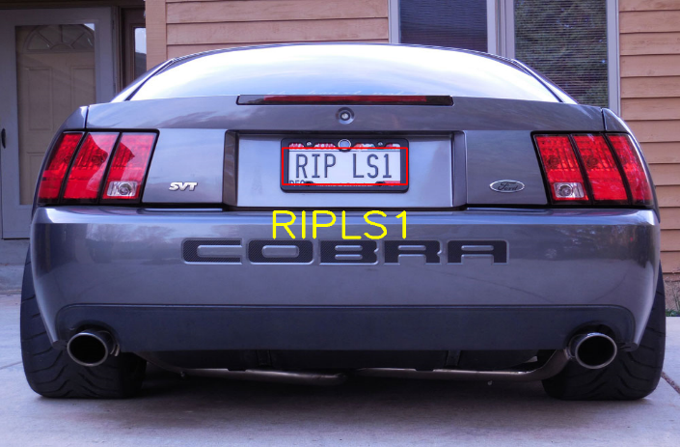

Input Image --



Output Image –



Analysis:-

We achieved all the requirements specified within the system and proposed the respective outputs of License plate localization using Automatic License Plate Recognition system. This system gives appropriate results even if the captured images is 20% blur, or blackened or got excessive light.

The defects that it undergoes is to obtain the character segmentation when the image obtained is blur for more than 35%, or do not undergoes character recognition if the license plate has fancy number and character fonts.

#### CONCLUSION

The obtained system is able to recognize the number plate of vehicle by localizing it and then segmenting and recognizing the characters of the number plate. And later track the vehicle after it is stolen from a certain place at certain time by localizing the vehicle from the ANPR database of nearby cameras in the given timespan and also establishing a route of the roads that vehicle travelled.

#### REFERENCES

* 1. Litman, T. 2013. Parking Management Strategies, Evaluation and Planning. Retrieved from http://www.vtpi.org/park_man.pdf
  2. Subraman T. 2012. Parking Study on Main Corridors in Major Urban Centre. International Journal of Modern Engineering Research (IJMER) ISSN: 2249-6645. Retrieved from http://www.ijmer.com/papers/vol2_issue3/AE23742748. pdf
  3. Cornwall. 2009. Drivers on police files for life. Retrieved from http://www.westbriton.co.uk/Drivers-police-fileslife/story-11398048-detail/story.html